Lab 6 – Panya Sukphranee

6.3.0 – Functions in Code
- output = get_spectrum(x, fs)
  - output is DTFT
- [peak_value, peak_index] = find_peak(spec, low, high)
  - Specify range of frequency to search in Hz
- freq = index_to_freq(index, total_points, sampling_freq)
  - convert peak index to angular frequency
- [b,a] = find_coeffs(omega)
  - Given omega, returns coefficients of numerator and denominator of H(z)

6.3.1 – Find Frequency of Corrupting Tone

Plot of Spectrum
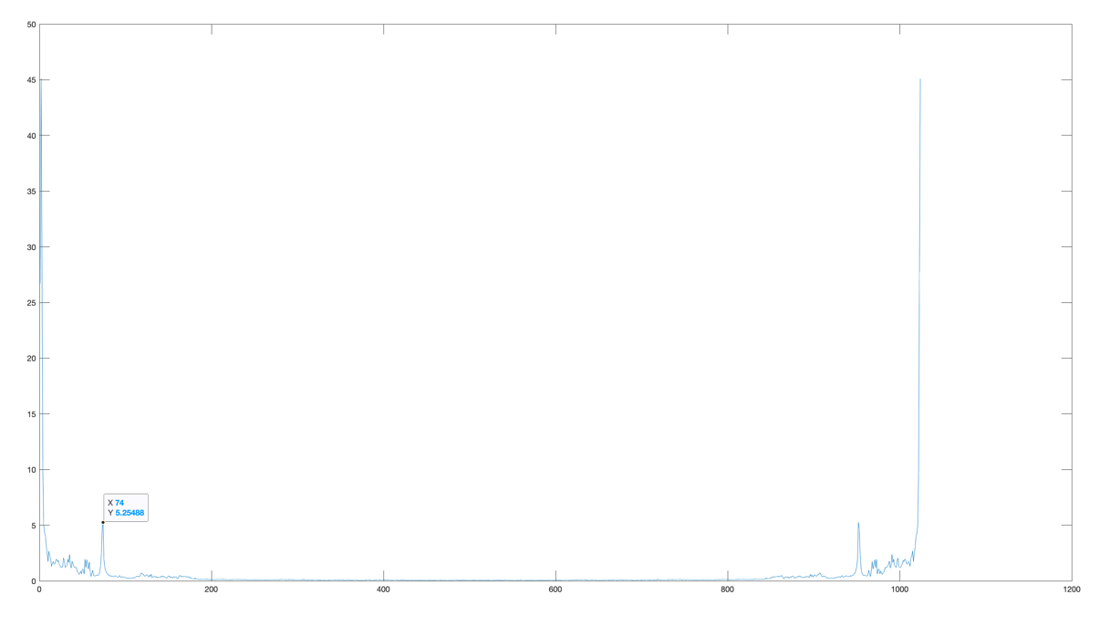
- Point of corrupting tone is 74, corresponding to about ~796Hz.

6.3.2 – Find Poles and Zeros of the Filter that will remove the tone

Magnitude of poles of notch filter are at \pm 0.45 radians and magnitude of 0.9.

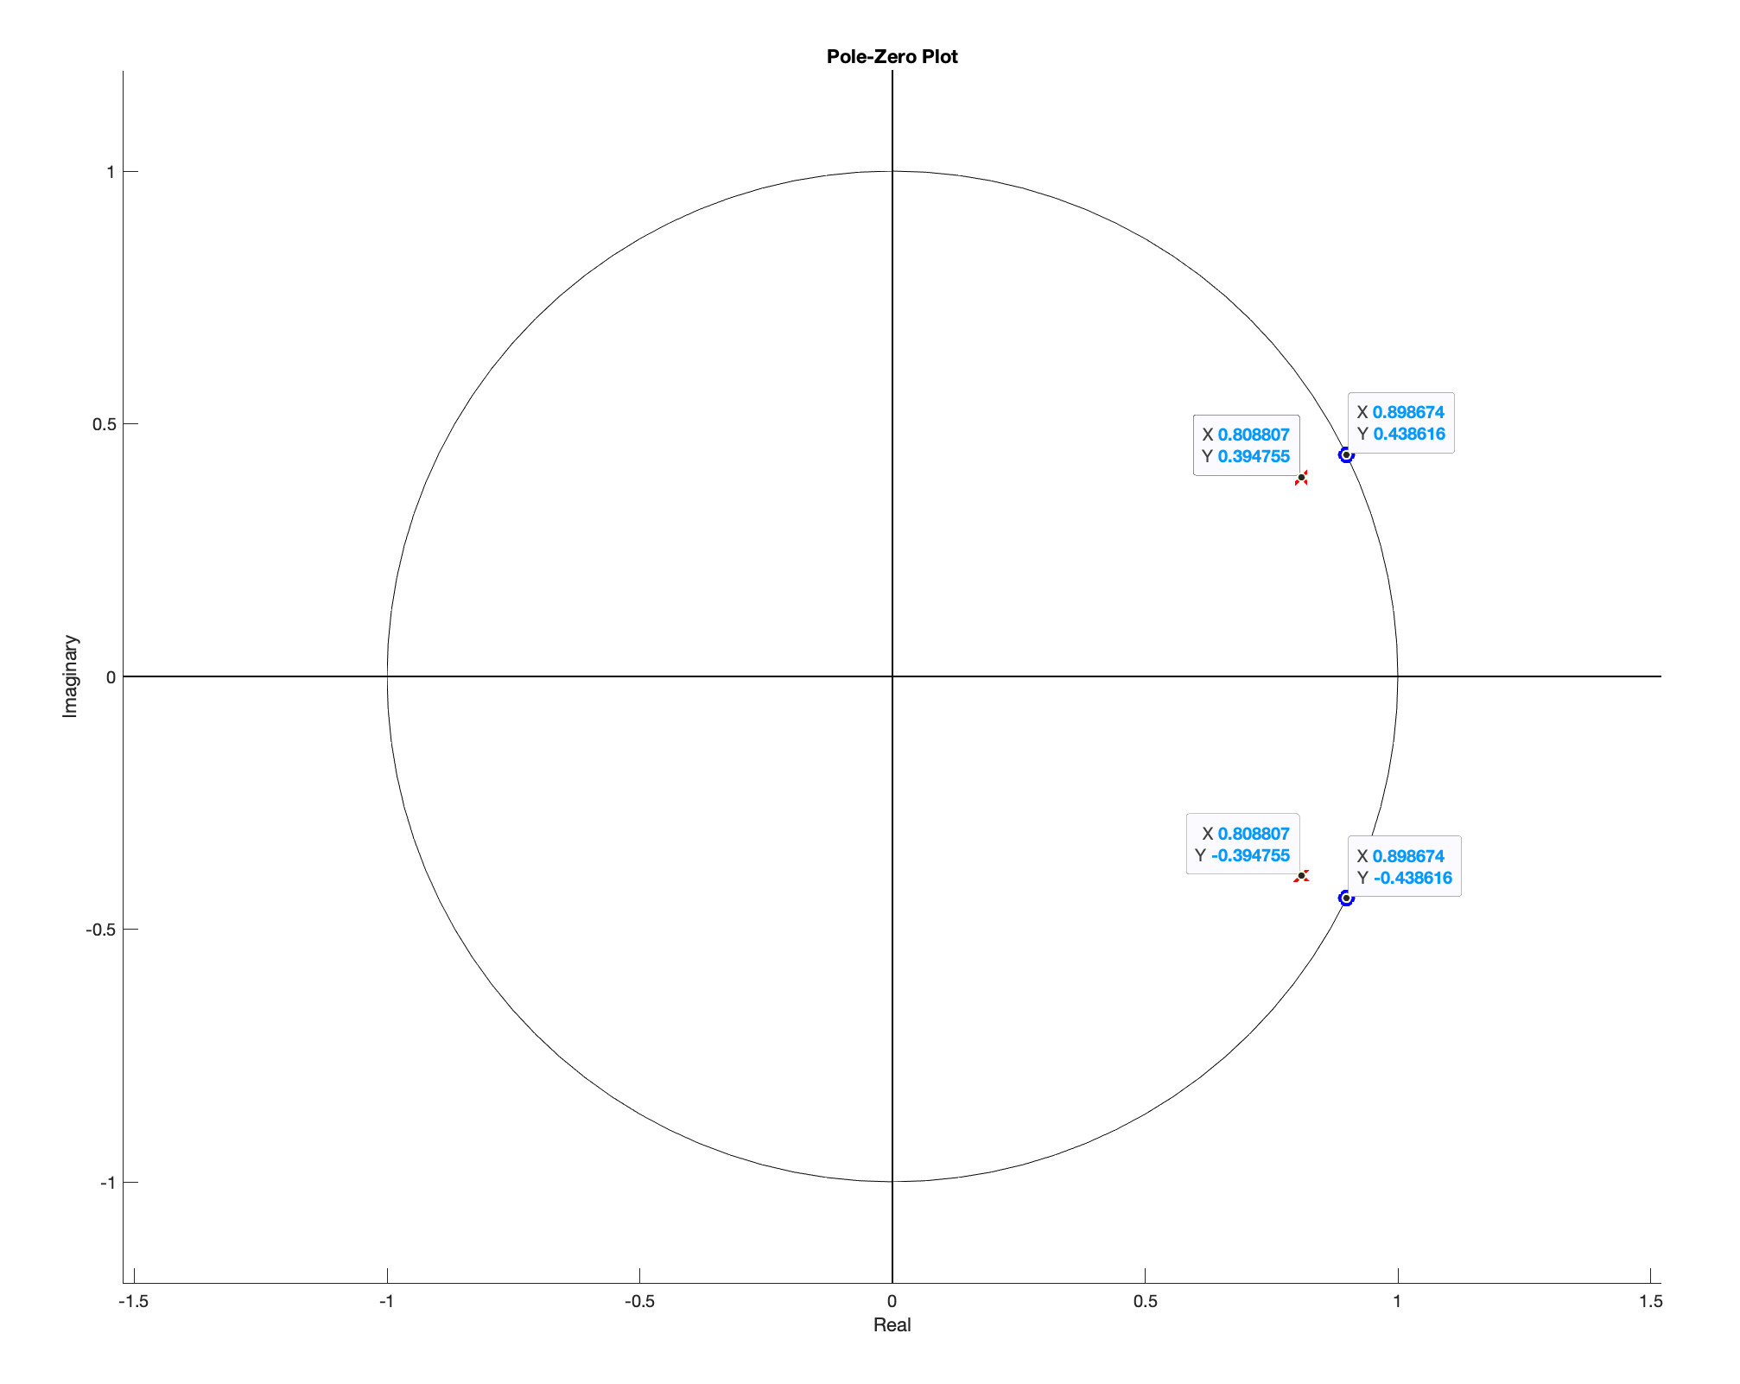

6.3.3 – Design the filter that will remove the tone

After removing the sound, we have the following spectrum
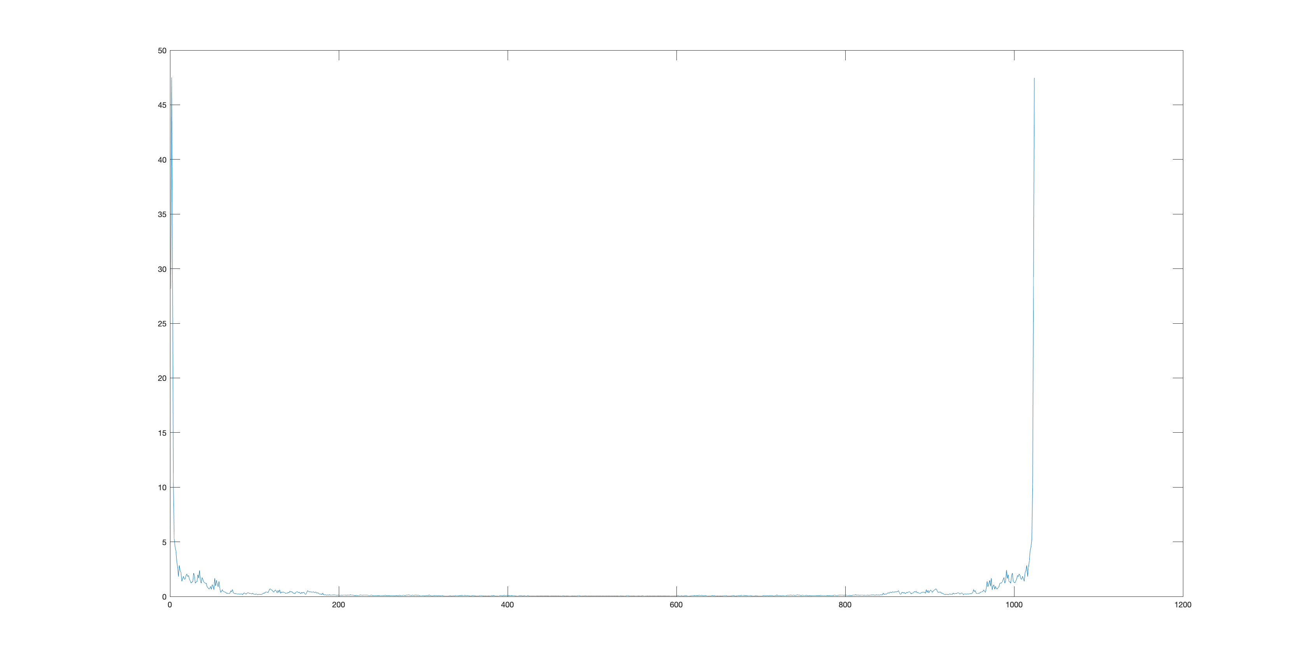

6.3.4 – Test you filter

The sound file sounds good. I have attached the code to this packet.

